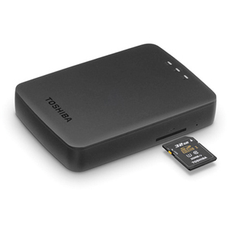

Toshiba 900 Portable SSD

Your laptop's short on storage, and you need a booster you can toss in a bag and carry without concern? Buying a portable external solid-state drive (SSD) is the obvious solution. SSDs are by their nature rugged—their lack of moving platters makes them immune to data loss due to bumps and jostling—but the Toshiba Extreme Portable SSD takes that up a level. This drive resists dust, water, and shock. Easy to clip on to a backpack or a belt loop, this SSD is a good choice for hikers, outdoor photographers, and media workers seeking additional space for photos, videos, and other digital media shot on the spot. It's utilitarian and a little chunky, perhaps a bit too big to put on your keychain, but it's light. Plus, it's a relatively fast performer, and the rugged design doesn't add too much to the price.

If you store all your data in the cloud, it might be hard to fathom an external hard drive doing double duty as a status symbol. That's exactly what the sleek, wildly fast, and eye-wateringly expensive Samsung Portable SSD X5 is, though. Following in the footsteps of both Samsung's own flagship external drives like the Portable SSD T5 and design-forward works of hard drive art from LaCie and others, the X5 offers copious amounts of solid-state storage at extreme speeds, thanks to its use of the cutting-edge Thunderbolt 3 and PCI Express NVMe interfaces. It would make a killer gift for Mac-bound video editors who shoot in 4K or photographers who work in RAW, but it's overkill for pretty much anyone else. If you store all your data in the cloud, it might be hard to fathom an external hard drive doing double duty as a status symbol. That's exactly what the sleek, wildly fast, and eye-wateringly X5 is, though. Following in the footsteps of both Samsung's own flagship external drives like the Portable SSD T5 and design-forward works of hard drive art from LaCie and others, the X5 offers copious amounts of solid-state storage at extreme speeds, thanks to its use of the cutting-edge Thunderbolt 3 and PCI Express NVMe interfaces. It would make a killer gift for Mac-bound video editors who shoot in 4K or photographers who work in RAW, but it's overkill for pretty much anyone else.

SPEC DATA:

Type:
External

Storage Capacity (as Tested):
2 TB

Rotation Speed:
SSD

Ports:
USB-C

